## Mini Project II

**(2020-2021)**

# Report File

***Tech Assessment Portal (Web Development)***



Department of Computer Science and Engineering GLA University, Mathura

|  |  |  |
| --- | --- | --- |
| **Submitted To:** | **Submitted By:** |  |
| Mr. Sharad Gupta | Isha Parveen | (181500278) |
| (Technical Trainer) | Utkarsh Rathor | (181500771) |
|  | Jayesh Gupta | (181500297) |
|  | Swati Saxena | (181500746) |
|  | Ritik Lamba | (181500577) |

**INDEX**

1. INTRODUCTION

2. ANALYSIS

2.1 SYSTEM ANALYSIS

2.2 SYSTEM SPECIFICATIONS

* + 1. 3. DESIGN APPROACH
    2. 3.1 INTRODUCTION TO DESIGN
    3. 3.2 UML DIAGRAMS
    4. 3.3 DATA FLOW DIAGRAMS
    5. 3.4 E-R DIAGRAMS

4. PROJECT MODULES

* + 1. 5. IMPLEMENTATION
    2. 4.1 CONCEPTS AND TECHNIQUES
    3. 4.2 TESTING

4.2.1 TEST CASES

* + 1. 6. OUTPUT SCREENS

7. CONCLUSION

8. FUTURE ENHANCEMENTS

9. BIBILIOGRAPHY

**INTRODUCTION**

Online examinations are an important method of evaluating the success potential of students. This research effort the individuals under consideration were students who would be enrolling in computer courses or Technologies Registrations. A prototype of a web-based placement examination system is described from the standpoint of the research effort, end user, and software development.

An on-line educational system including exam processing and electronic journal features. An instructor builds a course based questions which on-line contain in identification of assignments. Which are compiled into an on-line exam syllabus?

Users enrolled in the platform may access the electronic details they provided and perform various functions with the on-line educational system in order to participate in the on-line examinations. Users can receive an on-line exam, having multimedia content, for the course, and they can electronically provide answers for the exam. And after Completion of their duration of exam they are provided the grade or marks secured in their examinations.

**ANALYSIS**

**SYSTEM ANALYSIS**:

**1. Existing System**

Existing system is a manual one in which users are maintaining books to store the information like Student Details, Instructor Details, Schedule Details and feedbacks about students who attempted exam as per schedule.. It is very difficult to maintain historical data.

**DISADVANTAGES:**

The following drawbacks of existing system emphasize the need for computerization:

1. A lot of copies of question papers have to be made

2. A lot of correction work hence delay in giving the results

3. A lot of tabulation work for each subject results

**2. Proposed System**

This application is used to conduct online examination. The students can sit at individual terminals and login to write the exam in the given duration. The questions have to be given to the students. This application will perform correction, display the result immediately and also store it in database. This application provides the administrator with a facility to add new exams. This application provides the Instructor add questions to the exam, modify questions in the exam in a particular exam. This application takes care of authentication of the administrator, Instructor as well as the student.

**3. Objective of the System**

The objective of the Online Examination Tool is to provide better information for the users of this system for better results for their maintainence in student examination schedule details and grading details.

**System Specifications**

**Hardware Requirements:-**

* Pentium-IV(Processor).
* 256 MB Ram
* 512 KB Cache Memory
* Hard disk 10 GB
* Microsoft Compatible 101 or more Key Board

**Software Requirements: -**

* **Operating System : Windows**
* **Web-Technology: PHP**
* **Front-End: HTML,CSS,JAVASCRIPT**
* **Back-End: MySQL**
* **Web Server: Apache SERVER.**

**DESIGN**

Design is the first step in the development phase for any techniques and principles for the purpose of defining a device, a process or system in sufficient detail to permit its physical realization.

Once the software requirements have been analyzed and specified the software design involves three technical activities - design, coding, implementation and testing that are required to build and verify the software.

The design activities are of main importance in this phase, because in this activity, decisions ultimately affecting the success of the software implementation and its ease of maintenance are made. These decisions have the final bearing upon reliability and maintainability of the system. Design is the only way to accurately translate the customer’s requirements into finished software or a system.

Design is the place where quality is fostered in development. Software design is a process through which requirements are translated into a representation of software. Software design is conducted in two steps. Preliminary design is concerned with the transformation of requirements into data.

**UML Diagrams:**

Actor:  
 A coherent set of roles that users of use cases play when interacting with the use `cases.

Use case:

A description of sequence of actions, including variants, that a system performs that yields an observable result of value of an actor.

UML stands for Unified Modeling Language. UML is a language for specifying, visualizing and documenting the system. This is the step while developing any product after analysis. The goal from this is to produce a model of the entities involved in the project which later need to be built. The representation of the entities that are to be used in the product being developed need to be designed.

There are various kinds of methods in software design:

They are as follows:

* Use case Diagram
* Sequence Diagram
* Collaboration Diagram
* Activity Diagram
* State chat Diagram

**USECASE DIAGRAMS:**

Use case diagrams model behavior within a system and helps the developers understand of what the user require. The stick man represents what’s called an actor.

Use case diagram can be useful for getting an overall view of the system and clarifying who can do and more importantly what they can’t do.

Use case diagram consists of use cases and actors and shows the interaction between the use case and actors.

* The purpose is to show the interactions between the use case and actor.
* To represent the system requirements from user’s perspective.
* An actor could be the end-user of the system or an external system.

**USECASE DIAGRAM:**

A Use case is a description of set of sequence of actions. Graphically it is rendered as an ellipse with solid line including only its name. Use case diagram is a behavioral diagram that shows a set of use cases and actors and their relationship. It is an association between the use cases and actors. An actor represents a real-world object. Primary Actor – Sender, Secondary ActorReceiver.



**SEQUENCE DIAGRAM:**

Sequence diagram and collaboration diagram are called INTERACTION DIAGRAMS. An interaction diagram shows an interaction, consisting of set of objects and their relationship including the messages that may be dispatched among them.

A sequence diagram is an introduction that empathizes the time ordering of messages. Graphically a sequence diagram is a table that shows objects arranged along the X-axis and messages ordered in increasing time along the Y-axis

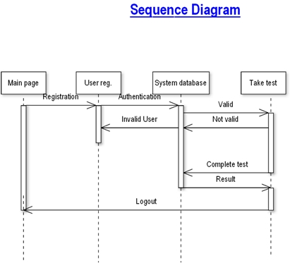

**COLLABORATION DIAGRAM:**

A collaboration diagram is an introduction diagram that emphasizes the structural organization of the objects that send and receive messages. Graphically a collaboration diagram is a collection of vertices and arcs.

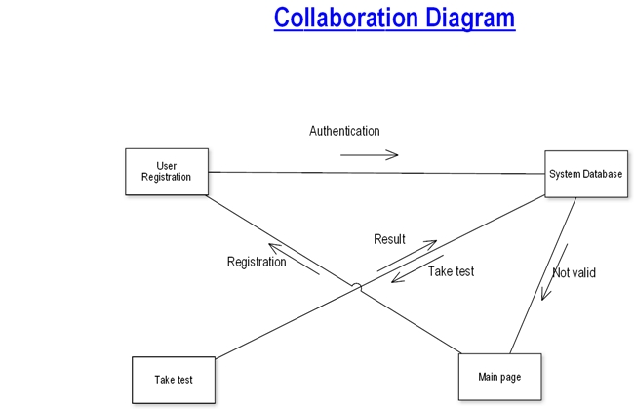

**CLASS DIAGRAM:**

Class is nothing but a structure that contains both variables and methods. The Class Diagram shows a set of classes, interfaces, and collaborations and their relating ships. There is most common diagram in modeling the object oriented systems and are used to give the static view of a system. It shows the dependency between the classes that can be used in our system.

The interactions between the modules or classes of our projects are shown below. Each block contains Class Name, Variables and Methods.

**CLASS:**

A description of set of objects that share the same attributes, operations, relationships, and semantics



**State Chart Diagram**

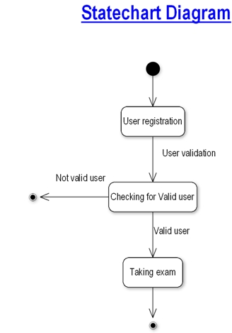

.

**DATA FLOW DIAGRAMS**:

The DFD takes an input-process-output view of a system i.e. data objects flow into the software, are transformed by processing elements, and resultant data objects flow out of the software.

Data objects represented by labeled arrows and transformation are represented by circles also called as bubbles. DFD is presented in a hierarchical fashion i.e. the first data flow model represents the system as a whole. Subsequent DFD refine the context diagram (level 0 DFD), providing increasing details with each subsequent level. The DFD enables the software engineer to develop models of the information domain & functional domain at the same time. As the DFD is refined into greater levels of details, the analyst perform an implicit functional decomposition of the system. At the same time, the DFD refinement results in a corresponding refinement of the data as it moves through the process that embody the applications.A context-level DFD for the system the primary external entities produce information for use by the system and consume information generated by the system. The labeled arrow represents data objects or object hierarchy.

**RULES FOR DFD:**

* Fix the scope of the system by means of context diagrams.
* Organize the DFD so that the main sequence of the actions
* Reads left to right and top to bottom.
* Identify all inputs and outputs.
* Identify and label each process internal to the system with Rounded circles.
* A process is required for all the data transformation and Transfers. Therefore, never connect a data store to a data Source or the destinations or another data store with just a Data flow arrow.
* Do not indicate hardware and ignore control information.
* Make sure the names of the processes accurately convey everything the process is done.
* There must not be unnamed process.
* Indicate external sources and destinations of the data, with Squares.
* Number each occurrence of repeated external entities.
* Identify all data flows for each process step, except simple Record retrievals.
* Label data flow on each arrow.
* Use details flow on each arrow.
* Use the details flow arrow to indicate data movements.

**DATAFLOW DIAGRAMS:**

**Database:**

User registrationn

Take Test

Database

**User Registration**

**User registration**

Register user

Search for user details

view user details

Update user details

**Taking Test**

**Taking Test**

Start Exam

View Result

End Exam

**E-R Diagrams:**

The Entity-Relationship (ER) model was originally proposed by Peter in 1976 [Chen76] as a way to unify the network and relational database views. Simply stated the ER model is a conceptual data model that views the real world as entities and relationships. A basic component of the model is the Entity-Relationship diagram which is used to visually represents data objects. Since Chen wrote his paper the model has been extended and today it is commonly used for database design For the database designer, the utility of the ER model is:

* it maps well to the relational model. The constructs used in the ER model can easily be transformed into relational tables.
* it is simple and easy to understand with a minimum of training. Therefore, the model can be used by the database designer to communicate the design to the end user.
* In addition, the model can be used as a design plan by the database developer to implement a data model in a specific database management software.

## *Connectivity and Cardinality*

The basic types of connectivity for relations are: one-to-one, one-to-many, and many-to-many. A *one-to-one* (1:1) relationship is when at most one instance of a entity A is associated with one instance of entity B. For example, "employees in the company are each assigned their own office. For each employee there exists a unique office and for each office there exists a unique employee.

A *one-to-many* (1:N) relationships is when for one instance of entity A, there are zero, one, or many instances of entity B, but for one instance of entity B, there is only one instance of entity A. An example of a 1:N relationships is

a department has many employees

each employee is assigned to one department

A *many-to-many* (M:N) relationship, sometimes called non-specific, is when for one instance of entity A, there are zero, one, or many instances of entity B and for one instance of entity B there are zero, one, or many instances of entity A. The connectivity of a relationship describes the mapping of associated

## 

## *ER Notation*

There is no standard for representing data objects in ER diagrams. Each modeling methodology uses its own notation. The original notation used by Chen is widely used in academics texts and journals but rarely seen in either CASE tools or publications by non-academics. Today, there are a number of notations used, among the more common are Bachman, crow's foot, and IDEFIX.

All notational styles represent entities as rectangular boxes and relationships as lines connecting boxes. Each style uses a special set of symbols to represent the cardinality of a connection. The notation used in this document is from Martin. The symbols used for the basic ER constructs are:

* **entities** are represented by labeled rectangles. The label is the name of the entity. Entity names should be singular nouns.
* **relationships** are represented by a solid line connecting two entities. The name of the relationship is written above the line. Relationship names should be verbs
* **attributes**, when included, are listed inside the entity rectangle. Attributes which are identifiers are underlined. Attribute names should be singular nouns.
* **cardinality** of many is represented by a line ending in a crow's foot. If the crow's foot is omitted, the cardinality is one.
* **existence** is represented by placing a circle or a perpendicular bar on the line. Mandatory existence is shown by the bar (looks like a 1) next to the entity for an instance is required. Optional existence is shown by placing a circle next to the entity that is optional

Modules of Tech-Assessment Portal

MODULES:

1. ADMIN MODULE

2. INSTRUCTOR MODULE

3. STUDENT MODULE

1. ADMIN MODULE:

1. REGISTER

2. LOGIN

3. CHANGE PASSWORD&FORGOTPASSWORD

4. STUDENT -MODIFING DETAILS

5. DEPARTMENTS-ENTERING/MODIFYING DETAILS

6. INSTRUCTOR DETAILS-MODIFYING DETAILS

1. REGISTER: To be authenticated first have to be registered.

1. LOGIN: The Registered User Can be Allowed to view inner details for which he Permitted
2. CHANGE PASSWORD & FORGOT PASSWORD User has rights to modify his login details & also be informed through mails if he is unable to login.

1. STUDENT -MODIFING DETAILS User can be modified to change status of each User.
2. DEPARTMENTS-ENTERING/MODIFYING DETAILS New departments adding and old departmentd deletions are spend by this user.

2. INSTRUCTOR MODULE:

1 . REGISTER

2. LOGIN

3.CHANGE PASSWORD&FORGOT PASSWORD

4. ADD QUESTIONS-DEPARTMENTS VERIFING.

5. UPDATE QUESTIONS -DEPARTMENTS VERIFING

6. CREATE EXAMS

7. UPDATE EXAMS

8. VIEW EXAM DETAILS- VIEW NO OF REGISTERED STUDENTS

VIEW NO OF ATTENDED STUDENTS

9. EVALUATE QUESTION: MULTIPLE CHOICE TRUE/FALSE

1. REGISTER: To be authenticated first have to be registered.
2. LOGIN :The Registered User Can be Allowed to view inner details for which he Permitted
3. CHANGE PASSWORD & FORGOT PASSWORD : User has rights to modify his loging details& also be informed through mails if he is unable to login
4. ADD QUESTIONS-DEPARTMENTS VERIFING : According to flow of questions & Technology he can add questions into the database.
5. UPDATE QUESTIONS -DEPARTMENTS VERIFING : If any corrections in data of questions he can modify them

1. CREATE EXAMS: He will be prepared schedule for exams periodically.
2. UPDATE EXAMS: He has rights to modify exam schedule.
3. VIEW EXAM DETAILS- VIEW NO OF REGISTERED STUDENTS,

VIEW NO OF ATTENDED STUDENT Can view at attended students who has registered.

1. EVALUATE QUESTION:MULTIPLE CHOICE

TRUE/FALSE: Evaluation of marks based on his initiations when adding questions

3. STUDENT DETAILS:

1. REGISTER

2. LOGIN

3. TAKE EXAM- MULTIPLE CHOICE TRUE/FALSE

4. SEE EXAM RESULTS

5. LOGOUT

1. REGISTER: To be authenticated first have to be registered
2. LOGIN: The Registered User Can be allowed to view inner details for which he Permitted
3. TAKE EXAM- MULTIPLE CHOICE, TRUE/FALSE:The registred student allowed to start the exam
4. SEE EXAM RESULTS: After Completion of exam he can view at his result.
5. LOGOUT: After the process of examination he turned to Logout page.

# OVERVIEW OF TECHNOLOGIES USED

**PHP**

PHP: Hypertext Preprocessor, is a widely used, general-purpose [scripting language](http://en.wikipedia.org/wiki/Scripting_language) that was originally designed for [web development](http://en.wikipedia.org/wiki/Web_development), to produce [dynamic web pages](http://en.wikipedia.org/wiki/Dynamic_web_page). It can be embedded into [HTML](http://en.wikipedia.org/wiki/HTML) and generally runs on a [web server](http://en.wikipedia.org/wiki/Web_server), which needs to be configured to process PHP code and create [web page](http://en.wikipedia.org/wiki/Web_page) content from it. It can be deployed on most web servers and on almost every [operating system](http://en.wikipedia.org/wiki/Operating_system) and [platform](http://en.wikipedia.org/wiki/Platform_(computing)) free of charge.

PHP was originally created by [Rasmus Lerdorf](http://en.wikipedia.org/wiki/Rasmus_Lerdorf) in [1995](http://en.wikipedia.org/wiki/1995) and has been in continuous development ever since. The main implementation of PHP is now produced by The PHP Group and serves as the [de facto standard](http://en.wikipedia.org/wiki/De_facto_standard) for PHP as there is no [formal specification](http://en.wikipedia.org/wiki/Formal_specification).PHP is [free software](http://en.wikipedia.org/wiki/Free_software) released under the [PHP License](http://en.wikipedia.org/wiki/PHP_License), which is incompatible with the [GNU General Public License](http://en.wikipedia.org/wiki/GNU_General_Public_License) (GPL) because of restrictions on the use of the term PHP

PHP has evolved to include a [command line interface](http://en.wikipedia.org/wiki/Command_line_interface) capability and can also be used in [standalone](http://en.wikipedia.org/wiki/Standalone_software) [graphical applications](http://en.wikipedia.org/wiki/Graphical_user_interface).

**USAGE**

PHP is a general-purpose scripting language that is especially suited for [web development](http://en.wikipedia.org/wiki/Web_development). PHP generally runs on a [web server](http://en.wikipedia.org/wiki/Web_server). Any PHP code in a requested file is [executed](http://en.wikipedia.org/wiki/Execution_(computing)) by the PHP runtime, usually to create [dynamic web page](http://en.wikipedia.org/wiki/Dynamic_web_page) content. It can also be used for [command-line](http://en.wikipedia.org/wiki/Command-line) scripting and [client-side](http://en.wikipedia.org/wiki/Client-side) [GUI](http://en.wikipedia.org/wiki/Graphical_user_interface) applications. PHP can be deployed on most [web servers](http://en.wikipedia.org/wiki/Web_server), many [operating systems](http://en.wikipedia.org/wiki/Operating_system) and [platforms](http://en.wikipedia.org/wiki/Platform_(computing)), and can be used with many [relational database management systems](http://en.wikipedia.org/wiki/Relational_database_management_system). It is available free of charge, and the PHP Group provides the complete source code for users to build, customize and extend for their own use.

PHP primarily acts as a [filter](http://en.wikipedia.org/wiki/Filter_(software)), taking input from a file or stream containing text and/or PHP instructions and outputs another stream of data; most commonly the output will be HTML. Since PHP 4, the PHP [parser](http://en.wikipedia.org/wiki/Parser) [compiles](http://en.wikipedia.org/wiki/Compiler) input to produce [byte code](http://en.wikipedia.org/wiki/Bytecode) for processing by the [Zend Engine](http://en.wikipedia.org/wiki/Zend_Engine), giving improved performance over its [interpreter](http://en.wikipedia.org/wiki/Interpreter_(computing)) predecessor

Originally designed to create dynamic web pages, PHP now focuses mainly on [server-side scripting](http://en.wikipedia.org/wiki/Server-side_scripting), and it is similar to other server-side scripting languages that provide dynamic content from a web server to a [client](http://en.wikipedia.org/wiki/Client_(computing)), such as [Microsoft](http://en.wikipedia.org/wiki/Microsoft)'s [Active Server Pages](http://en.wikipedia.org/wiki/Active_Server_Pages), [Sun Microsystems](http://en.wikipedia.org/wiki/Sun_Microsystems)' [JavaServer Pages](http://en.wikipedia.org/wiki/JavaServer_Pages) and [mod_perl](http://en.wikipedia.org/wiki/Mod_perl). PHP has also attracted the development of many [frameworks](http://en.wikipedia.org/wiki/Software_framework) that provide building blocks and a design structure to promote [rapid application development](http://en.wikipedia.org/wiki/Rapid_application_development) (RAD). Some of these include [CakePHP](http://en.wikipedia.org/wiki/CakePHP), [Symfony](http://en.wikipedia.org/wiki/Symfony), [CodeIgniter](http://en.wikipedia.org/wiki/CodeIgniter), and [Zend Framework](http://en.wikipedia.org/wiki/Zend_Framework), offering features similar to other [web application frameworks](http://en.wikipedia.org/wiki/List_of_web_application_frameworks).

**About HTML**

HTML, which stands for Hyper Text Markup Language, is the predominant [markup language](http://en.wikipedia.org/wiki/Markup_language) for [web pages](http://en.wikipedia.org/wiki/Web_page). It provides a means to create [structured documents](http://en.wikipedia.org/wiki/Structured_document) by denoting structural [semantics](http://en.wikipedia.org/wiki/Semantic) for text such as headings, paragraphs, lists etc as well as for links, quotes, and other items. It allows [images and objects](http://en.wikipedia.org/wiki/HTML_element#Images_and_objects) to be embedded and can be used to create [interactive forms](http://en.wikipedia.org/wiki/HTML_element#Forms). It is written in the form of [HTML elements](http://en.wikipedia.org/wiki/HTML_element) consisting of "tags" surrounded by [angle brackets](http://en.wikipedia.org/wiki/Brackets#Angle_brackets_or_chevrons_.3C_.3E) within the web page content. It can include or can load [scripts](http://en.wikipedia.org/wiki/Scripting_language) in languages such as [JavaScript](http://en.wikipedia.org/wiki/JavaScript) which affect the behavior of HTML processors like [Web browsers](http://en.wikipedia.org/wiki/Web_browser); and [Cascading Style Sheets](http://en.wikipedia.org/wiki/Cascading_Style_Sheets) (CSS) to define the appearance and layout of text and other material. The [W3C](http://en.wikipedia.org/wiki/W3C), maintainer of both HTML and CSS standards, encourages the use of CSS over explicit presentational markup.

Hyper Text Markup Language(HTML) is the encoding scheme used to create and format a web document. A user need not be an expert programmer to make use of HTML for creating hypertext documents that can be put on the internet.

Most graphical [e-mail](http://en.wikipedia.org/wiki/E-mail) clients allow the use of a subset of HTML (often ill-defined) to provide formatting and [semantic](http://en.wikipedia.org/wiki/Semantic_web) markup not available with [plain text](http://en.wikipedia.org/wiki/Plain_text). This may include typographic information like coloured headings, emphasized and quoted text, inline images and diagrams. Many such clients include both a [GUI](http://en.wikipedia.org/wiki/GUI) editor for composing HTML e-mail messages and a rendering engine for displaying them. Use of HTML in e-mail is controversial because of compatibility issues, because it can help disguise [phishing](http://en.wikipedia.org/wiki/Phishing) attacks, because it can confuse [spam](http://en.wikipedia.org/wiki/E-Mail_spam) filters and because the message size is larger than plain text.

**NAMING CONVENTIONS**

The most common [filename extension](http://en.wikipedia.org/wiki/Filename_extension) for [files](http://en.wikipedia.org/wiki/Computer_file) containing HTML is .html. A common abbreviation of this is .htm, which originated because some early operating systems and file systems, such as [DOS](http://en.wikipedia.org/wiki/DOS) and [FAT](http://en.wikipedia.org/wiki/File_Allocation_Table), limited file extensions to [three letters](http://en.wikipedia.org/wiki/8.3_filename).

**HTML APPLICATION**

An HTML Application is a [Microsoft Windows](http://en.wikipedia.org/wiki/Microsoft_Windows) application that uses HTML and Dynamic HTML in a browser to provide the application's graphical interface. A regular HTML file is confined to the security model of the web browser, communicating only to web servers and manipulating only webpage objects and [site cookies](http://en.wikipedia.org/wiki/HTTP_cookie). An HTA runs as a fully trusted application and therefore has more privileges, like creation/editing/removal of files and [Windows Registry](http://en.wikipedia.org/wiki/Windows_Registry) entries. Because they operate outside the browser's security model, HTAs cannot be executed via HTTP, but must be downloaded (just like an [EXE file](http://en.wikipedia.org/wiki/EXE)) and executed from local file system

**ABOUT MySQL**

## MySQL Introduction

There are a large number of database management systems currently available, some commercial and some free. Some of them : Oracle, Microsoft Access, Mysql and PostgreSQL.  
These database systems are powerful, feature-rich software, capable of organizing and searching millions of records at very high speeds.

### Understanding Databases, Records, and Primary Keys

Every Database is composed of one or more tables.These Tables, which structure data into rows and columns, Impose organization on the data.The records in a table(below) are not arranged in any particular order.To make it easy to identify a specific record,therefore, it becomes necessary

### standing Relationships and Foreign Keys(RDBMS)

You already know that a single database can hold multiple tables.  
In a Relational database management system(RDBMS), these tables can be linked to each other by one or more common fields, called **foreign keys**.

### What is Database administrator(DBA) ?

Database administrator is the super user of database, he has unrestricted rights and privileges to access database, grant permission to other database users.

### What is Database user(DBU) ?

Database user is the person who uses the database in a restricted privileges, provided by database administrator.

### Download MySQL Database

If you have installed PHP’s WAMP or XAMPP server, then mysql database already exists. if you don’t have then download mysql database from here[http://www.mysql.com](http://www.phptpoint.com/mysql/)

**DATABASE TABLES:**

USER REG TABLE

|  |  |  |  |
| --- | --- | --- | --- |
| NAME | NULL/NOTNULL | TYPE | KEY |
| ID | NOTNULL | INT | PRIMARYKEY |
| NAME | NULL | VARCHAR(50) |  |
| DOB | NULL | DATETIME |  |
| GENDER | NULL | VARCHAR(10) |  |
| BRANCH | NULL | VARCHAR(20) |  |
| COLLEGE | NULL | VARCHAR(50) |  |
| UID | NULL | VARCHAR(50) |  |
| PWD | NULL | VARCHAR(20) |  |
| RPWD | NULL | VARCHAR(20) |  |
| UTYPE | NULL | VARCHAR(20) |  |
| QUE | NULL | VARCHAR(500) |  |
| ANS | NULL | VARCHAR(500) |  |

True/False Based Question Table

|  |  |  |  |
| --- | --- | --- | --- |
| NAME | NULL/NOTNULL | TYPE | KEY |
| ID | NOTNULL | INT | PRIMARYKEY |
| QUE | NULL | VARCHAR(500) |  |
| AW | NULL | VARCHAR(500) |  |

True/False Based Answer Table

|  |  |  |  |
| --- | --- | --- | --- |
| NAME | NULL/NOTNULL | TYPE | KEY |
| ID | NOTNULL | INT | FOREIGNKEY |
| AW | NULL | VARCHAR(500) |  |

Options Based Question Table

|  |  |  |  |
| --- | --- | --- | --- |
| NAME | NULL/NOTNULL | TYPE | KEY |
| QID | NOTNULL | INT | PRIMARYKEY |
| QN | NULL | VARCHAR(500) |  |
| OPTIONS1 | NULL | VARCHAR(100) |  |
| OPTIONS2 | NULL | VARCHAR(100) |  |
| ANSWER | NULL | VARCHAR(100) |  |

Options Based Answers

|  |  |  |  |
| --- | --- | --- | --- |
| NAME | NULL/NOTNULL | TYPE | KEY |
| QID | NOTNULL | INT | FOREIGNKEY |
| ANSWER | NULL | VARCHAR(10) |  |

All Student Marks

|  |  |  |  |
| --- | --- | --- | --- |
| NAME | NULL/NOTNULL | TYPE | KEY |
| ID | NULL | INT |  |
| MARKS | NULL | INT |  |

Exam Schedule

|  |  |  |  |
| --- | --- | --- | --- |
| NAME | NULL/NOTNULL | TYPE | KEY |
| ENAME | NULL | VARCHAR(30) |  |
| EDATE | NULL | DATETIME |  |

**FEASIBILITY STUDY:**

Feasibility study is conducted once the problem is clearly understood. Feasibility study is a high level capsule version of the entire system analysis and design process. The objective is to determine quickly at a minimum expense how to solve a problem. The purpose of feasibility is not to solve the problem but to determine if the problem is worth solving.

The system has been tested for feasibility in the following points.

1. Technical Feasibility

2. Economical Feasibility

3. Operational Feasibility.

**1. Technical Feasibility**

The project entitles "Courier Service System” is technically feasibility because of the below mentioned feature. The project was developed in Java which Graphical User Interface.

It provides the high level of reliability, availability and compatibility. All these make Java an appropriate language for this project. Thus the existing software Java is a powerful language.

**2. Economical Feasibility**

The computerized system will help in automate the selection leading the profits and details of the organization. With this software, the machine and manpower utilization are expected to go up by 80-90% approximately. The costs incurred of not creating the system are set to be great, because precious time can be wanted by manually.

**3. Operational Feasibility**

In this project, the management will know the details of each project where he may be presented and the data will be maintained as decentralized and if any inquires for that particular contract can be known as per their requirements and necessaries.

**Implementation:**

Implementation is the stage where the theoretical design is turned into a working system. The most crucial stage in achieving a new successful system and in giving confidence on the new system for the users that it will work efficiently and effectively.

The system can be implemented only after thorough testing is done and if it is found to work according to the specification.

It involves careful planning, investigation of the current system and its constraints on implementation, design of methods to achieve the change over and an evaluation of change over methods a part from planning. Two major tasks of preparing the implementation are education and training of the users and testing of the system.

The more complex the system being implemented, the more involved will be the systems analysis and design effort required just for implementation.

The implementation phase comprises of several activities. The required hardware and software acquisition is carried out. The system may require some software to be developed. For this, programs are written and tested. The user then changes over to his new fully tested system and the old system is discontinued.

**FUTURE ENHANCEMENTS:**

This application avoids the manual work and the problems concern with it. It is an easy way to obtain the information regarding the different scheduled examinations information that are currently issued.

Well I and my team members have worked hard in order to present an improved website better than the existing one’s regarding the information about the various activities. Still, we found out that the project can be done in a better way. Primarily, when we request information about a particular schedules it just shows the exam date and platform. So, after getting the information we can get access to the Tech-Assessment Portal

The enhancement that we can add the searching option. We can directly search to the particular student details from this site.

**OUTPUT**

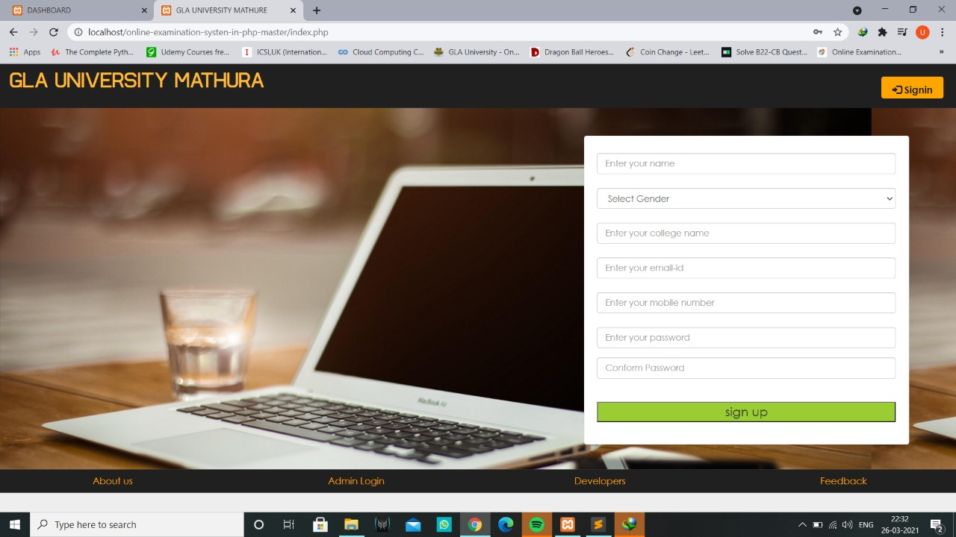

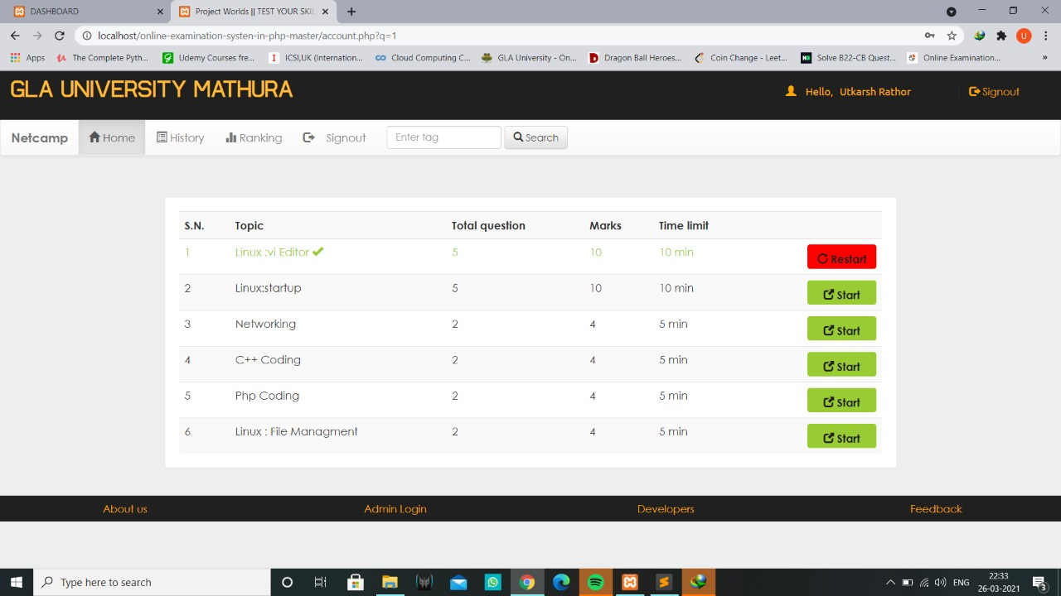

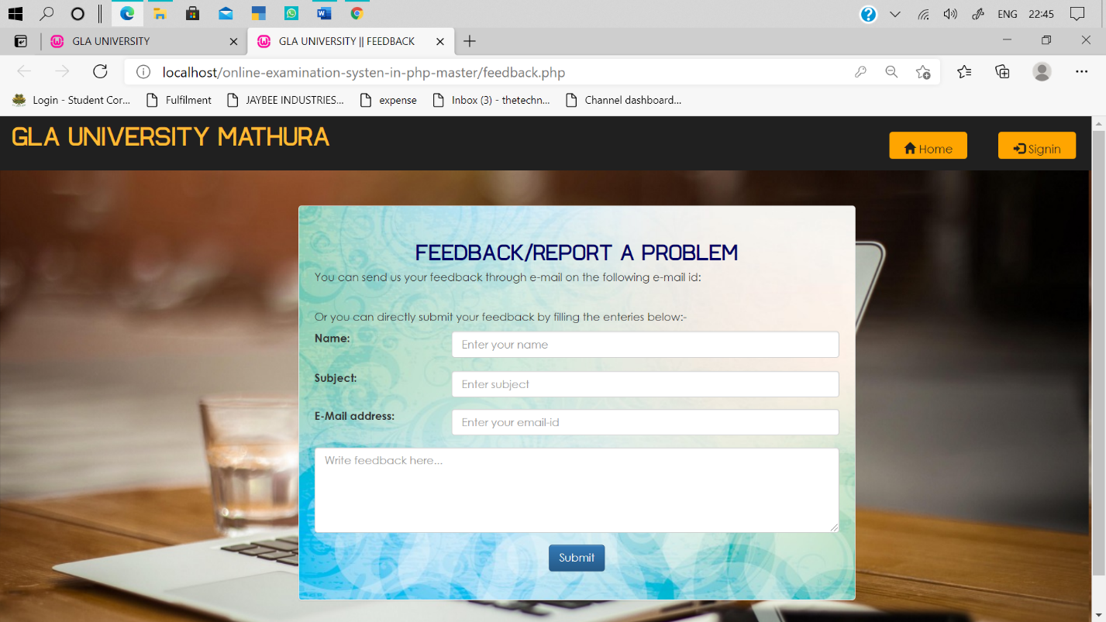

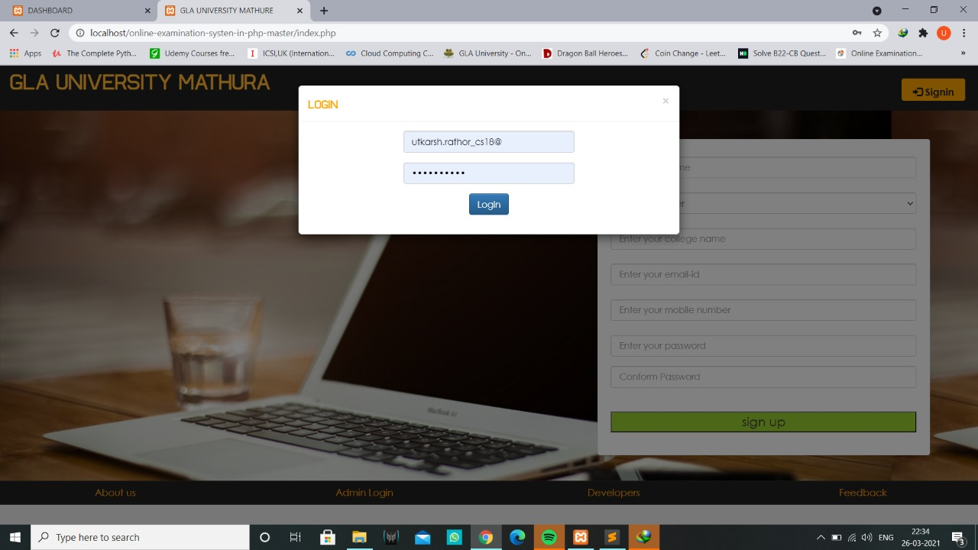

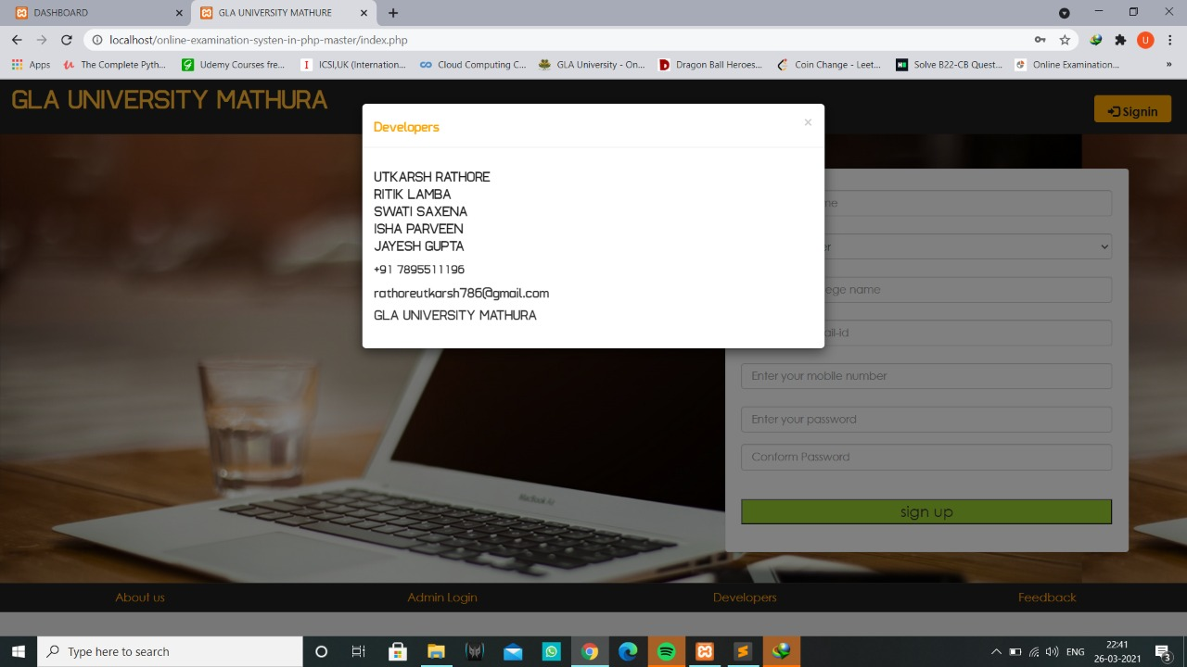



**CONCLUSION:**

The package was designed in such a way that future modifications can be done easily. The following conclusions can be deduced from the development of the project.

* Automation of the entire system improves the efficiency
* It provides a friendly graphical user interface which proves to be better when compared to the existing system.
* It gives appropriate access to the authorized users depending on their permissions.
* It effectively overcomes the delay in communications.
* Updating of information becomes so easier.
* System security, data security and reliability are the striking features.
* The System has adequate scope for modification in future if it is necessary.

**REFERENCES**

* [www.google.com](http://www.google.com)
* [www.w3school.com](http://www.w3school.com)
* [www.youtube.com](http://www.youtube.com)
* [www.javatpoint.com](http://www.javatpoint.com)

**Faculty Guidelines**

* **Mr. Sharad Gupta**

(Technical Trainer , GLA University)